Junction
The camp sprawls before you, salvors hurrying to their next point of work – or their break – underscored by hammer blows, welding work and distant gunfire. You try to ignore the crescendo to decide on your next destination.
A servor bot helpfully presents the scheduled exploration party departures.
Habitation
“Ah.” She exhales, flatly.
Not a trace of warmth. Certainly no deference.
“I’m the expedition lead. We’re departing for the local hab-sphere within the hour. Captain, with all due respect, I don’t see the sense in you tagging along.”
- Are you expecting resistance? In a Hab section?
Another sigh, heavier this time. “Not exactly. But I’ve seen supposedly unpowered autoturrets light up and turn someone into paste. Freshlings, especially, seem to attract that.”
“I’d rather you not be one of them. Not on my watch.”
You get the sense her concern has more to do with “her watch” than about you getting shot.
- I’m just here to sightsee.
- My ship, my rules.
“Sure. Chasing some romance of discovery, the thrill of it all. You’ll hate it.”
“Exploration is mind-numbingly boring, right until it isn’t, and that’s when a newbie turns into a corpse. Or worse, a liability.”
You’ve heard this sort of speech before.
- You don’t want me around, I take it.
“No.”
- Are you quite finished?
- So, when do we leave?
A pause. She doesn’t look at you, but turns to the crew.
“Pack it up. We’re moving.”
The camp stirs, suddenly alive. Whatever her attitude, these people are pros. It shows.
- Continue
Her TriPad lights up just as she turns back toward you. She glances at the screen, clearly more interested in that than your face. Her expression shifts; focused, then uneasy, then irritated.
She looks up, sharp.
“And now it’s a liability even without the traps. Scouts just flagged recent human activity.”
A pause.
“Can you at least bring someone with a big gun? So it’s not my name on the report when you catch a bullet?”
- It’ll be your name anyway.
“Thank you for the gracious reminder. Now, reinforcements?”
- You’ll do just fine without.
- Order a marine detachment to accompany you.

Entire block is empty
Light shines in from the massive glass windows in the ceiling far above, night ambience.
Halls upon hall, dome upon dome abandoned.
Older sections have genuine wooden furniture turned to dust, leaving only colour differences on the metal where they once stood
There is a hydroponics section locked down, with roots growing out of broken panels
Come across central communal area with a real decorative well – incredibly decadent
There’s engravings on the well detailing some history:
- Construction at an unspecified point in the past
- Used to power a volume of space and enable quick travel
- Grand civilization living aboard, thriving
- Panel showing them holding up a tunnel-like object
Your party gets spooked by a sound.
OPTION: You can now request backup marines. Not doing so is stupid, but you get made fun of by the chief salvor who’s a snarky cunt bordering on insubordination.
OPTION: follow the sound.
OPTION ignore
1 IF follow:
Find clear traces of humans, not habitation, but moving
You are not alone here, and your guards increase their attention level by three levels.
Somehow(??) segue towards meeting local inhabitants of the derelict station (civilized, though tribal)
- They had their relic stolen and they contact you if you follow them. You barely understand them, they speak a language that’s not even in the translator archives anymore, and can only be TLd by using a gamma core
  - They should be inhospitable and morally in the right but also feel like dicks
- They hunt a thief that took a relic of theirs and want your support
You can agree to hunt the guy
2 IF you agree to hunt the guy:
- Hunt him with marines = success no casualties
- Hunt him with no marines = 10 crew get shot but success
- He has the relic and tells you that he’s an explorer that stranded here 20 years ago, fills in the details on things:
  - Crucible is broken
  - Some of the original inhabitants stayed and now roam or inhabit spaces
  - It’s so large there are multiple villages strewn about just in this hab section, but none have the know how, resources or tech to fix it, and there are no operable ships left
  - He wants to trade the relic for passage off this place (and is an officer)
    - Initial plan was to trade it to a larger local faction for residency and a pension
- You can negotiate to return the relic and gain him as lvl6 officer and get more info on what happened to the crucible (C to G) from the locals
- Or you can just take the relic and evacuate him to an indie planet / get him as officer
- Or you can take the relic and abandon him for lols
2 OR you do not agree to hunt him and he contacts you on his own with the same info and thanks you for not doing a manhunt but you lose out on the option to learn more by trading in the relic

1 IF you do not follow
You hear gunfire in the distance
- Thief contacts you over comms and requests help cause he has a comms tripad and the locals do not bc tech level
- If you do not meet up you instead encounter the locals and move to step 1 IF follow
- If you do meet up you arrive just as he is caught and get the full package of thief arguing his stuff and the locals wanting their relic back
  - Side with the thief: if you have marines, you either scare the locals or shoot them (causes the thief to not want to join as officer later)
    - If no marines: story point bullshit them, or try to convince them to trade relic for huge amounts of food, or other things, weapons?
    - If you don’t wanna trade they just demand the relic back but let you keep the guy (lvl 6 officer) in exchange for supplies
  - Side with the locals: you get him as officer but lose the relic by demanding his unharmed release in exchange for supplies
You return to camp after this, either:
- With the relic
- With the relic and the guy
- With the guy
- With nothing
The relic is a broken wormhole anchor
You can have it repaired for 100 relic components at Galatia
Full crucible timeline:
- Construction at an unspecified point in the past
- Used to power a volume of space and enable quick travel
- Grand civilization living aboard, thriving
- Panel showing them holding up a tunnel-like object
- Something happened and lots of people moved away from the crucible
- The remaining are barely enough to keep everything running but it was no longer as important as before anyway
- An attack forces a sudden move
- That move leaves them stranded at the ass end of nowhere (persean sector)
- Crucible is broken, hypertech is broken
- People start moving out in search of habitable planets
- Some stayed and now roam or inhabit spaces
- It’s so large there are multiple villages strewn about just in this hab section, but none have the know how, resources or tech to fix it, and there are no operable ships left

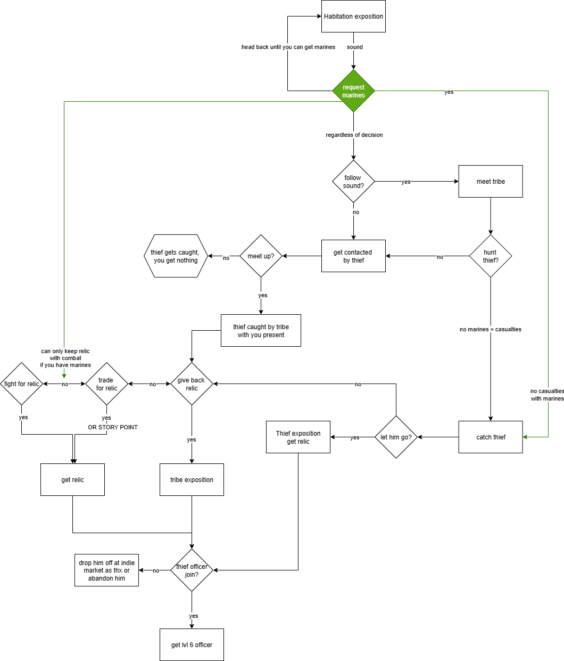
Engineering
allows you to turn power on
Control
If power on, open hangar doors
- also allows you to turn crucible on

Cargo
“’Tis less of a cargo hold an’ more of a cargo town, bossman.”
The grizzled salvor leading the sizeable exploration party greets you with no hint of decorum.
“Just wishin’ it weren’t locked up so good. Ya can see the goodies sparklin’ in the distance but ya can’t get at them, what with the doors shut tighter than...” He stops, brain kicking into gear as he remembers who he's talking to.
...tighter than?
“Well, boss, ya ken those nuns the Ludds keep over at their lil’ churchies?”
You really should have seen this one coming.
- Moving on.
- Just stare at him
“Ya, boss, so, as I was sayin’” - he fakes a cough - “them doors be shut. An’ as if that weren’t enough, they got some serious heat coverin’ for ’em too. Makes the trip a wee bit tricky unless ya got an army stored up your high quarters.”
A pause - “Sir.”
You ignore the slip and check the dossier on the preliminary survey to confirm – the entire area is swarming with car-sized, spider-like maintenance bots.
“They’s gots laser eyes.”
He’s probably not joking.
I got an army. (200 marines) | No army, but guns. (100 heavy weapons) | You will figure it out. (nothing)
You delay the trip to the holds for the sizeable marine contingent to arrive at the camp. The noise of heavy power armor echoes around you as they assemble into their combat groups.  The salvor chief whispers something under his breath. You catch only a few words, but it sounds suspiciously like an insult.  "Well, ain't this a bloody parade. If I’d known we’d be marchin’ in a proper legion, I’da brought me finest hat."  - Will these do?  He looks at you, at the marines, then back at you. “there goes my booze stocks.”  They will do. | You watch crate upon crate of heavy gear be unloaded from the shuttles arriving at the base camp – there’s even a few mechs.  The salvor chief lets out a low whistle – you take it as approval.  “That’s gonna help.”  - That’s it? Just ‘gonna help’?  “Oh, aye. Gonna help a whole lot.”  You watch one of the crewmen fumble and panic-drop a missile launcher. | The salvor chief looks unhappy about that.  “Are ya sure, boss? Ya seen the reports, this is gonna be rough without support.”  - Rough isn’t impossible.  “Aye, well, neither’s suicide.”.

- Reconsider (show army options again)
[Army options should show a “Return at a later time” Option]
If selected, greet with:
"Yer back! We’ve been waitin’ patiently. What’cha got for us?"
It was the kind of patience that came in a flask, judging by his breath.
- “Good luck!” (stay and wait for the report, skip the dialogues)
- “Let’s move.” (go with them)
The salvor chief stops you.
“A moment, boss, if ya would.” He unearths a bottle from the depths of his attire and saunters over to the assembled engineering team. A short, very gruff speech about proper tool maintenance later, they each take a turn to receive a shot of whatever is in that bottle – which, judging by the color, may well be motor oil. It would not be the strangest ritual you have seen salvors perform.
He hands you the bottle.
“Wards against death, that.”
- Drink
It is motor oil. You manage not to throw up.
- Excuse yourself
“Suit y’self. Don’ blame me if ya get impaled on a stick.”
- Continue
Mil | Wep | Nothing
The salvors’ entirely inappropriate songs echo through the tunnels as your convoy marches alongside the military contingent.  It is an uneventful trip, save for a few encounters with the spider-bots, which barely have a chance to react before getting disabled. The mood of your team is good as you approach the entry to the cargo areas. | Your convoy moves down the tunnels like a merry band of decidedly over-geared bandits, mech in tow. The errant spider or two gets dealt with by enthusiastic gunfire, and the mood is high. It is clear, however, that these crewmen are not professionals at handling the weapons they were given. | Your convoy slowly creeps through the service tunnels, avoiding spiders and other hazards through experience and luck. The mood is tense – this is a dangerous expedition, and the lack of proper firepower does nothing to alleviate their fear.  The salvor chief hums something uncomfortably close to a funeral dirge as the team presses on toward the cargo areas.

- Continue
The service tunnel exits into a cavernous three-lane transport intersection, entirely devoid of activity. Two cargo platforms lie crashed across the channels, their agrav systems long dead. Debris from the wreckage obstructs your path but not your line of sight to the cargo section doors-so massive that your neck aches just looking up. The faded numbers painted across them dwarf even a decent frigate, as do the deadlock bars locking them in place.
“told ya it was shut.”
- can you open them?
IF POWER ON
“If ya gits find me a working console!” he yells towards a group of junior scouts who looks much too young to be here.
They scamper off, returning with a location just a short while later. You notice one of them limping when they weren’t before-salvor life is not easy.
- continue
Despite his colourful character, the chief is nothing if not capable. Within minutes, the flickering console is hooked up to a communication suite, an uplink established, and the “bit-crunchers,” as he calls your fleet’s technical team, get to work. You sit back to check some reports.
Mil | Wep | Nothing
Your marines proceed to set up a forward operating base, fortifying the area with auto-turrets, barriers, drone patrols, and even a mobile scanner. | The salvors, in between their usual work, reinforce the location as best they can-repurposing debris into makeshift barriers and setting up auto-turrets. | The salvors, in between their usual work, construct makeshift barriers and weld doors shut. Just in case, they say.

- continue
“Stand clear!”
Your reading is cut short as the massive deadlocks disengage with a bone-rattling clang. Age-old dust and debris fall from walls and ceilings, dislodged by the vibrations of ship-sized gears turning to retract the bolts. An alarm starts wailing.
Any awe you might have felt at the sheer scale of the mechanism is quickly overshadowed by the sight of dozens of mechanical spiders pouring from the walls-drawn in by the unauthorized access alerts.
Looks like the security systems also got powered.
- continue
Mil | Wep | Nothing
Your marines immediately open fire. With their experience, gear and the relatively low number of enemies the problem is quickly taken care of with minimal casualties.  You also get to confirm that the spiders do, in fact, have laser eyes. | Your crew is surprised, but not routed, opening fire almost as quickly as the auto-turrets do. Missiles go everywhere as people yell and you are dragged towards the evac route by a familiar, limping junior scout. You get halfway there before the combat ends; the spiders having been dispatched – though not without casualties.  15 crew lie dead. | And all hell breaks loose. The barriers hold but for a moment as your crew starts running for their lives. A familiar, steady hand grabs you and shoves you towards the evac route.  “Run, bossman! I’ll be right behind ya!”
- continue  The doors groan as they drag open, sluggish with age, kicking up yet more dust into the stale air.  “That’s why I do it.”  The now-familiar voice pipes up beside you. The salvor chief stands there, watching the yawning doorway with something almost like reverence. “Can’t beat this moment.”  Your comms light up – the backup salvage parties are arriving. With the all-clear given, they move in, ready to strip whatever’s easily accessible and transport it back to your fleet.  - Continue  The chief exhales, shaking his head with a lopsided grin. “Boss, I’ll see ya around. Thanks for comin’ with. Been a right honor.”  This was certainly an experience.  - Shake his hand and return to camp  DISPLAY LOOT REPORT |  | - Continue  Your personal guard appears around you and escorts you back to the tunnels under fire.  You catch one last glance of the cargo doors moving to open, illuminated by panicked small-arms fire and red laser beams.  - Return to camp
IF POWER NOT ON
“Gonna be hard as hell, that. With this place as dead as the abyss, we’ll have to cut through the bulkhead-an’ that’ll rouse the spiders somethin’ fierce. They hate us breakin’ their stuff.”
He taps a recent burn scar on his temple.
“Learned that one already.”
This might go smoother if you find a way to restore power first.
- Let’s come back later. -> back to camp
- Let’s go.
The scouts are dispatched to check for promising breach points, returning with results just a few minutes later. You notice one of them limping with a fresh wound on their leg. Salvor life is not an easy life.
The team moves toward the bulkheads. No obvious defences are in sight, but the walls are lined with hive-like exits-dark openings set at unnatural heights, clearly not designed for human use. Even the more seasoned crew members shoot wary glances at them.
- continue
Once at the location your team gets to work, hauling out the bulky cutting torches and preparing the camp. Sparks flare as the first pilot flames ignite, the glow casting jagged shadows along the corridor.
Mil | Wep | Nothing
Your marines proceed to set up a forward operating base, fortifying the area with auto-turrets, barriers, drone patrols, and even a mobile scanner. | The salvors, in between their usual work, reinforce the location as best they can-repurposing debris into makeshift barriers and setting up auto-turrets. | The salvors, in between their usual work, construct makeshift barriers and weld doors shut. Just in case, they say.

- Continue
You try to catch up on some reports, but there is a strange, nagging feeling of wrong-ness pulling at your nerves ever so slightly, making it hard to concentrate. The sparks of the welding torches cast shimmering lights on the nearby surfaces, their glitter losing itself within the dark recesses of the massive, echoing halls.
You hear a ringing siren in the distance.
And the walls come alive as hundreds upon hundreds of mechanical spiders crawl out of the vents.
- continue
Mil | Wep | Nothing
The marines fight with precision, cutting down waves of mechanical spiders, but the swarm is relentless. They fall back in formation, bodies piling around them-friend and foe alike. The air fills with smoke, scorched metal, and the acrid stench of burning flesh.  The salvor’s torches burn on. | Panic grips the crew as the walls vomit forth an unrelenting tide of mechanical death. Plasma bolts and ballistic fire rip through the first waves, but it’s like scooping water from a sinking ship with your bare hands. A stray explosion sends a section of the ceiling collapsing, crushing friend and foe alike.  A familiar, limping junior scout grabs you by the arm, his face bloodied. "We have to go! We have to-” | There is no fight. No resistance. Just running.  The walls vomit steel nightmares, and your crew breaks. Someone screams, and then another, and then the hallways are filled with nothing but raw terror. The air thickens with the scent of ozone and burning flesh as lasers carve through fleeing bodies.
- continue  By the time the onslaught slows to a sustainable rate, two hundred marines have been reduced to fifty. The crewmen are not unscathed, either.  The bulkhead is breached a short while later, and the marines move to secure a supply corridor.  - continue  Within this relative safety, the transport parties move in, ready to strip whatever’s easily accessible and transport it back to your fleet.  You find the chief organizing triage. He gives you a tired nod. "I’ll see ya around, Boss."  This was certainly an experience.  - Return to camp  DISPLAY LOOT REPORT | - Run.  A mechanical leg skewers through his gut. He doesn’t even scream. His body is yanked backward into the horde as your guards cover your retreat to the tunnels with excessive firepower.  - Return to camp | - Run.  Your guards half shove, half drag you towards the tunnels, their path illuminated by the light of full-auto plasma fire. You see them shooting at anything that moves within the smoke and dust.  Anything.  - Return to camp

RETURN TO CAMP AFTER FAILURE
The salvor chief is not amongst the survivors
Shame the fuck out of the player
Any future action done through random npc #120 in a passive voice
Min 300 marines for future action because the salvage crews do not trust your ass and the place is now swarming
You can’t go with em, add some extra dialogue rubbing that in

